Current Daily Price of Various Commodities from Various Markets (Mandi)

Project Overview and Objective
- This project analyses daily mandi price data of agricultural commodities across India.
- It aims to identify price trends, regional variations, and market patterns.
- The insights help support farmers and policymakers in making informed market decisions.

Data Sources
- Source Description and Timeline: Open Government Data (OGD) Platform India. It is Released Under-National Data Sharing and Accessibility Policy (NDSAP) and generated through the AGMARKNET Portal (http://agmarknet.gov.in) .
- Published On: 23/05/2013
- Updated On: 06/11/2025
- Domain: Agriculture and Market Price

Problem Statement
- To summarize and understand the existing mandi price data across different states and districts in India.
- To identify the reason behind price fluctuations.
- To forecast future price trends of major commodities using historical mandi data.
- To provide insights and recommendations that can help farmers, traders, and
policymakers make better market and pricing decision.

Attribute (Column /Features) Details:
Attribute Name | Data Type | Description
State | Categorical (Text) | The state where market is located
District | Categorical (Text) | The district corresponding to the market
Market | Categorical (Text) | The specific agricultural market
Commodity | Categorical (Text) | The type of agricultural product traded
Arrival Date | Numeric (Date) | The date on which the commodity price was recorded
Modal Price | Numeric (Currency) | The most common or average price at which the commodity was sold

Tools & Technologies
- Excel: Data cleaning, transformation, removing duplicates and formatting the dataset.
- Power BI: Data modelling, DAX calculations, visualization, and interactive dashboard creation.

Data Pre-Processing (Excel / Power Query)

Tasks Performed:
- Data Loading: Imported the CSV file into Excel for initial inspection.
- Creating Sheet: To create a sheet to differentiate raw and cleaned dataset for easily understand.
- Header Formatting: Bolded and highlighted the header row.
- Removing Blank Rows: Deleted completely blank rows and columns to maintain data consistency.
- Removing Duplicates: Used Remove Duplicates feature to make each record is unique.
- Data Type Correction: Change all the numeric columns (like min price, max price, modal price) as currency type and Arriaval date column were in Date type.
- Sorting & Filtering: Sorted data by State, district, and commodity to make analysis easier.
- Saving Cleaned File: This dataset was saved as Cleaned_dataset.xlsx for further analysis in power BI.

Data Modelling and DAX (Power BI)
- Data Model: It is built using a single dataset-Which contain commodity-wise price details across different states and district. since all fields are present in one table, a Flat File Model is used.

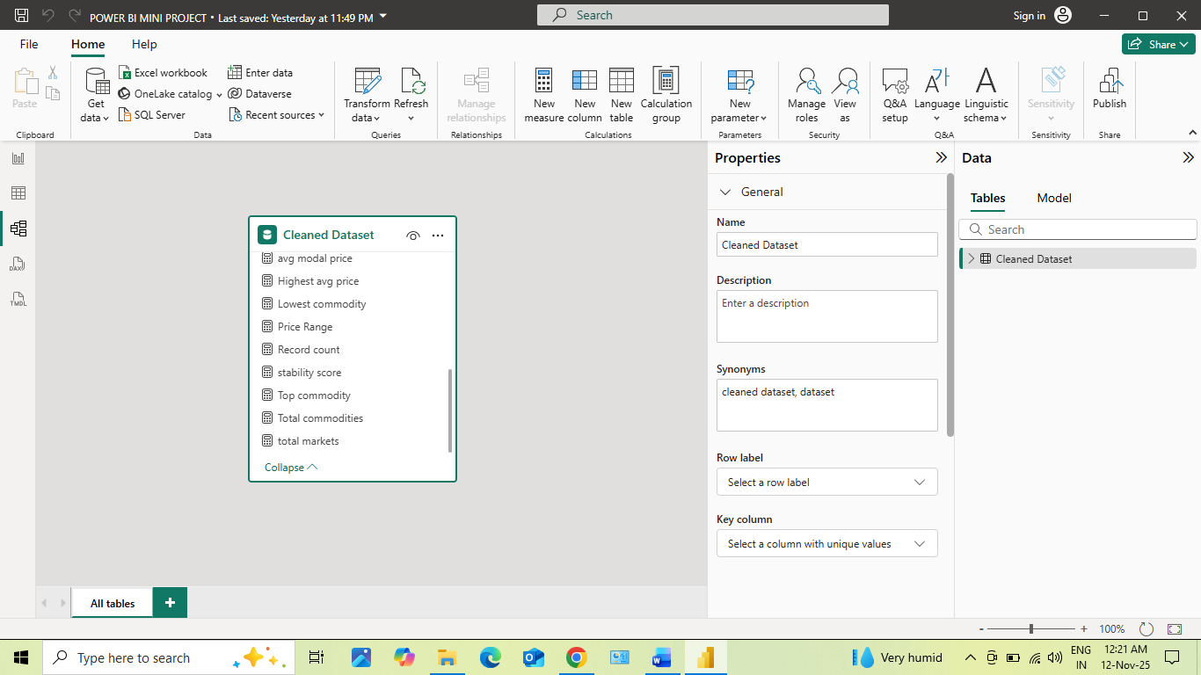
- DAX Measures: It was created to perform Descriptive, Diagnostic, Predictive, and Prescriptive Analysis such as Avg price, Avg Max, Avg Min, Avg model Price, Price Range, Highest avg Price, Top Commodity, Lowest Commodity, Record Count, Stability score.

Analysis and Visualizations (Power BI)

Dashboard Features:
- Multiple Visualizations based on problem statement: Bar charts, line charts, pie charts, cards, and Conditional Formatting tables to communicate insights.
- Make your Report interactive Layout using Drill-down, Filters and slicers
Clear Titles for each visuals & Labels.
- The power BI dashboard is designed as a consolidated report combining all four level of analysis.
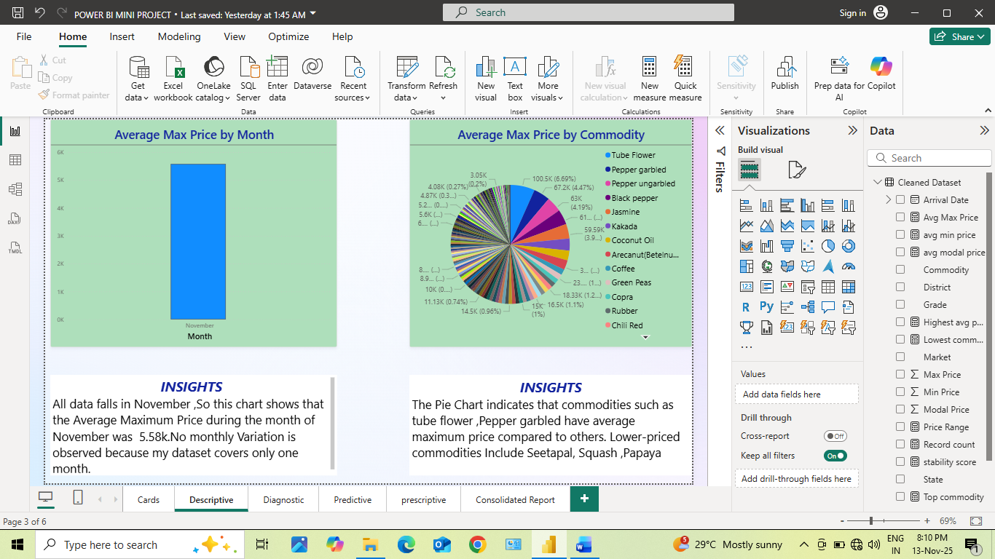

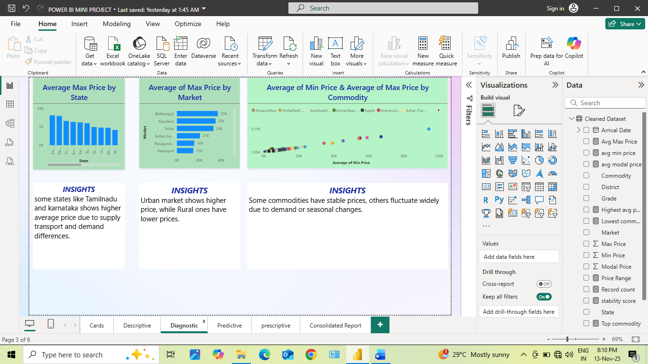
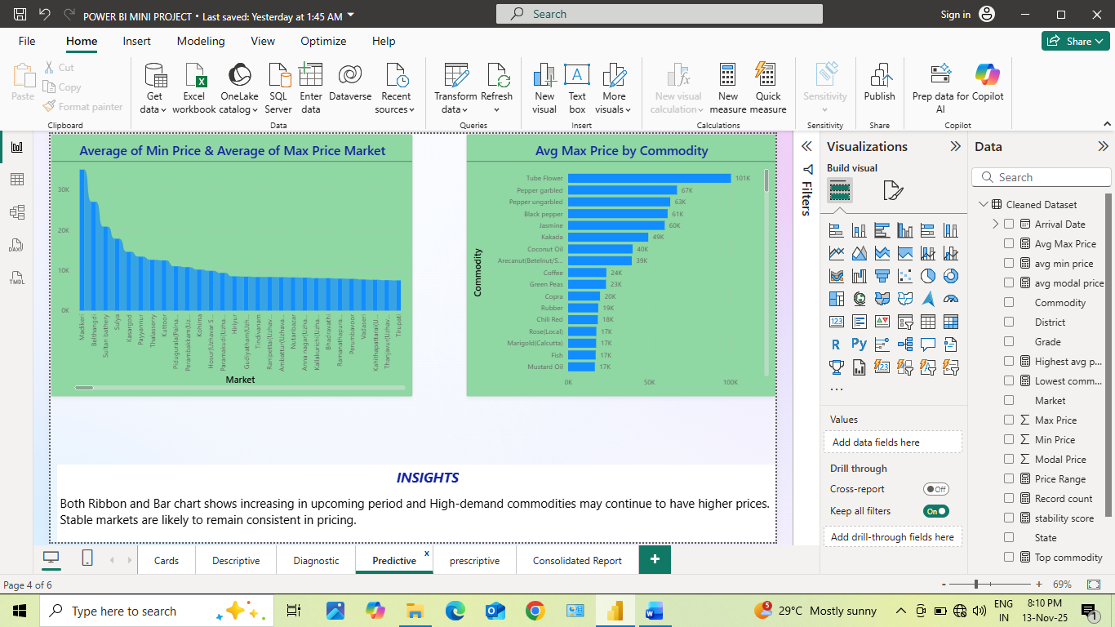
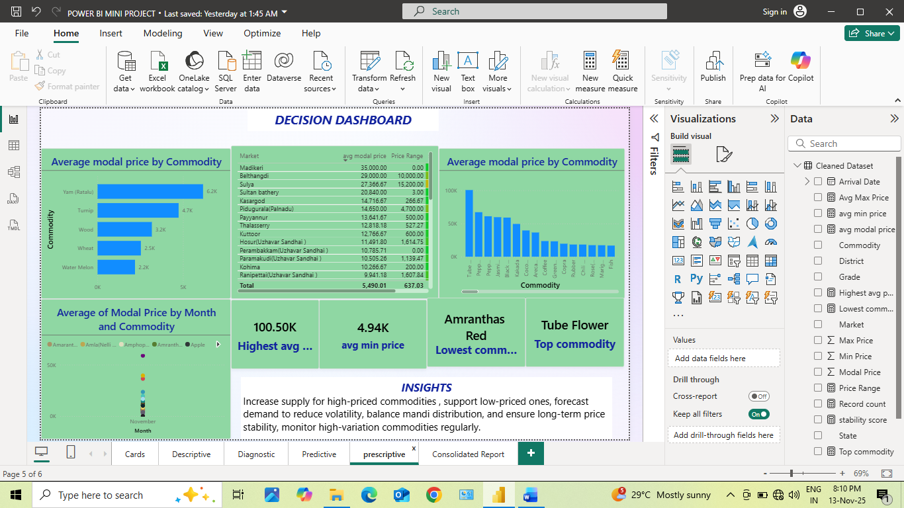

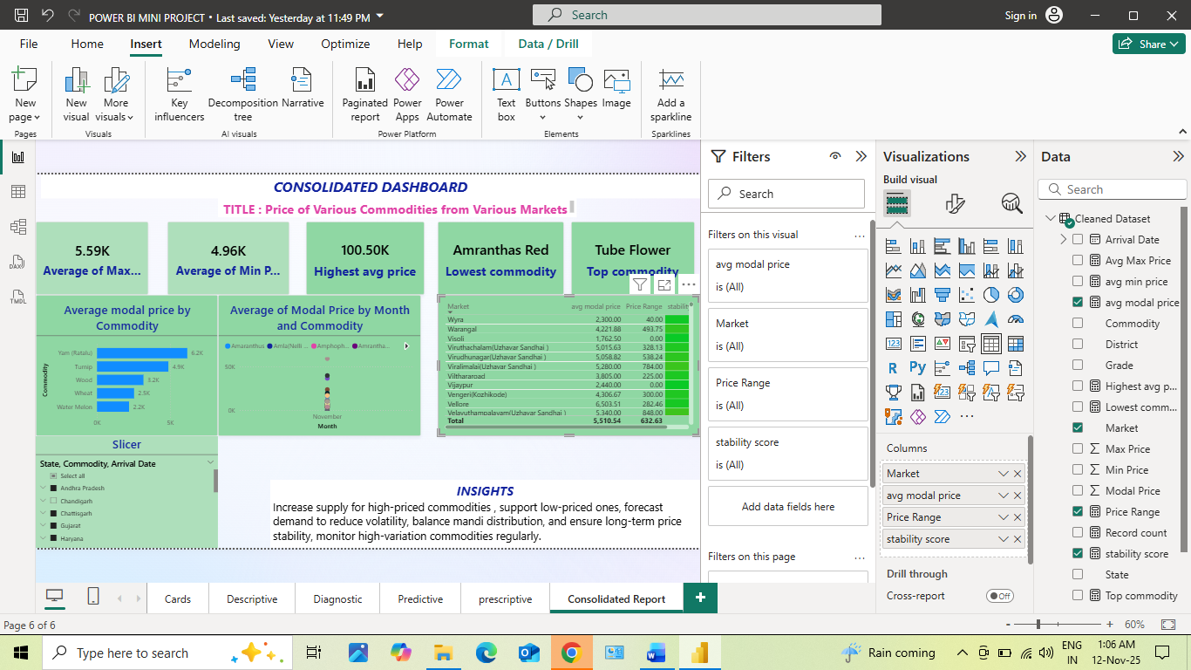

Insights & Conclusions
- Key Findings: “High commodity price variation observed across market, Stable market identified, future increase, recommended improving supply balance and storage planning in the data.
- Analysis insights:
Descriptive Analysis:
- This analysis summarizes Average price by month and commodities
- Average Maximum Price during the month of November was 5.58k
- Highest-priced commodities are tube flower, pepper garbled.
- Lowest-priced commodities are Squash, papaya.
Diagnosis Analysis:
- Tamilnadu and karnataka shows higher average price due to supply transport and demand differences.
- Some commodities have stable price.
Predictive Analysis:
- I predict Madikeri, Belthangdi market continues to have higher price.
- Tube flower, pepper garbled price also going to peak in a future.
Prescriptive Analysis:
- The table shows stability score highest value as Green colour, lowest price as red colour.
- I recommended to increase the supply of High-priced commodities like tube flower to stabilize their market price.
- At the same time, promote and support production of low-priced commodities
- Regularly monitoring the price trends.

Conclusions
The overall analysis provide complete understanding of the dataset. The descriptive identified key trends and variations in the commodity price. The diagnosis explained the reason behind these variations. The predictive projected possible future price movements, helping to anticipate changes. finally prescriptive offer the actionable recommendations, such as increase the supply of High-priced commodities like tube flower to stabilize their market price, promote and support production of low-priced commodities. Together, these analyses support informed decision-making and market sustainability.

